Guadalupe Flores

December 8, 2019

IT FDN 100 A

Assignment 09

Intro to Programming (Python) Module 9

# Introduction

In the ninth module includes a lecture on learning modules and how we would use them. The textbook summarized how to write and import modules and how to create new classes and how to combine objects to create more complex ones.

# Webpages and Web Articles

In addition to reading the chapter 9 in the textbook, we were assigned to review webpages on the subject of what the definition of a module is, and how to use it. It is considered the same as a code library and can contain functions and variables. See figure 1. The websites ae noted below:

* GeeksforGeeks: <https://www.geeksforgeeks.org/python-locals-function/>
* Python Modules: <https://www.w3schools.com/python/python_modules.asp>
* Python Modules and Packages – An Introduction: <https://realpython.com/python-modules-packages/>

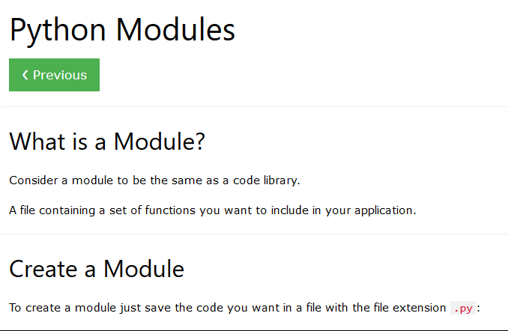 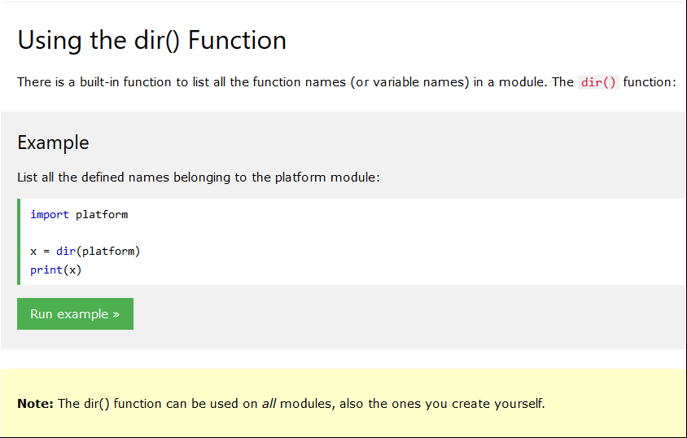

***Figure 1: Python Module: https://www.w3schools.com/python/python\_modules.asp***

# Applying our Knowledge

After reviewing the required reading, lecture notes, videos, and web pages, we then were required to complete an assignment for Module 9. The assignment includes creating three scripts modules, plus a main module creating a folder and subfolder titled Assignment 09. See Figure 2.

Machine generated alternative text:
Project Files • 
C:\_PythonClass 
> 
> 
> 
> 
> 
> 
> 
> 
> 
> 
> 
> 
> 
.idea 
chapterl 1 
chapter 1 2 
Mod01 
• Mod02 
Mod03 
• Mod04 
D Mod05 
D Mod06 
• Mod07 
D Mod08 
• Mod09 
Assignment09 
chapter09 
Mod9PythonProgrammingNotes.pdf 
Assignment09.pdf 
Mod09Listingszip 
Mod 10 
Syllabus _ Supporting_Documents 
Assignment09.py 
# Ti tLe: Assignment 9 
# Description: Working with Modules 
# ChangeLog: (Who, When, What) 
# RRoot, I . I .2030, Created started script 
# RRoot, I . I .2030, Added pseudo-code to start assignment 9 
# GFLores, 12.2.20190, Modified code to complete the assignment 9 
- # TODO: Import Modules (DONE) 
11 
if 
name 
maln 
from DataCIasses import Employee as Emp 
from import Fileprocessor as Fp 
from IOCIasses import Em I eelO as E io 
else: 
raise Exception ("This file was not created to be imported") 
- # Main Body of Script-- 
- # Data # 
IstEmpIoyeeTabIe = 
IstFiIeData = 
# A ist/tabLe of Employee objects 
# A List/ table of string objects in a List 
- # TODO: Add Data Code to the Main body (DONE) 
- # Load data from file ionto a List of employee objects when starts 
IstFiIeData = F p. 
for row in IstFiIeData: 
IstEm 
rowCI), rowC2) . strip())) 
# Show user a menu of options 
while True: 
stroptipp = 
Eio. # Get users menu option choice 
if stroption 

***Figure 2: Assignment 09 Subfolder***

# Creating the Program Script

The objective of the assignment was to create a main script, and within that same script were imported class modules. The imported modules were “DataClasses,” “ProcessingClasses,” and “IOclasses” See figure 3.

Machine generated alternative text:
Project Files • 
C:\_PythonClass 
> 
> 
> 
> 
> 
> 
> 
> 
> 
> 
> 
> 
> 
.idea 
chapterl 1 
chapter 1 2 
Mod01 
• Mod02 
Mod03 
• Mod04 
D Mod05 
D Mod06 
• Mod07 
D Mod08 
• Mod09 
Assignment09 
chapter09 
Mod9PythonProgrammingNotes.pdf 
Assignment09.pdf 
Mod09Listingszip 
Mod 10 
Syllabus _ Supporting_Documents 
Assignment09.py 
# Ti tLe: Assignment 9 
# Description: Working with Modules 
# ChangeLog: (Who, When, What) 
# RRoot, I . I .2030, Created started script 
# RRoot, I . I .2030, Added pseudo-code to start assignment 9 
# GFLores, 12.2.20190, Modified code to complete the assignment 9 
- # TODO: Import Modules (DONE) 
11 
if 
name 
maln 
from DataCIasses import Employee as Emp 
from import Fileprocessor as Fp 
from IOCIasses import Em I eelO as E io 
else: 
raise Exception ("This file was not created to be imported") 
- # Main Body of Script-- 
- # Data # 
IstEmpIoyeeTabIe = 
IstFiIeData = 
# A ist/tabLe of Employee objects 
# A List/ table of string objects in a List 
- # TODO: Add Data Code to the Main body (DONE) 
- # Load data from file ionto a List of employee objects when starts 
IstFiIeData = F p. 
for row in IstFiIeData: 
IstEm 
rowCI), rowC2) . strip())) 
# Show user a menu of options 
while True: 
stroptipp = 
Eio. # Get users menu option choice 
if stroption 

***Figure 3: Entering header information and imported modules in PyCharm for Module9***

# Running the Script

To test out your script in PyCharm select Run from the task menu. A lower console should open, with a Menu of Options. The user has four options. If the user selects “1) Show current employee data.” The program will show the current data and or “Add a new employee data” or “Save employee data to file.” The program will continue to loop until the user’s selection of option ” “Exit Program. See Figure 4.

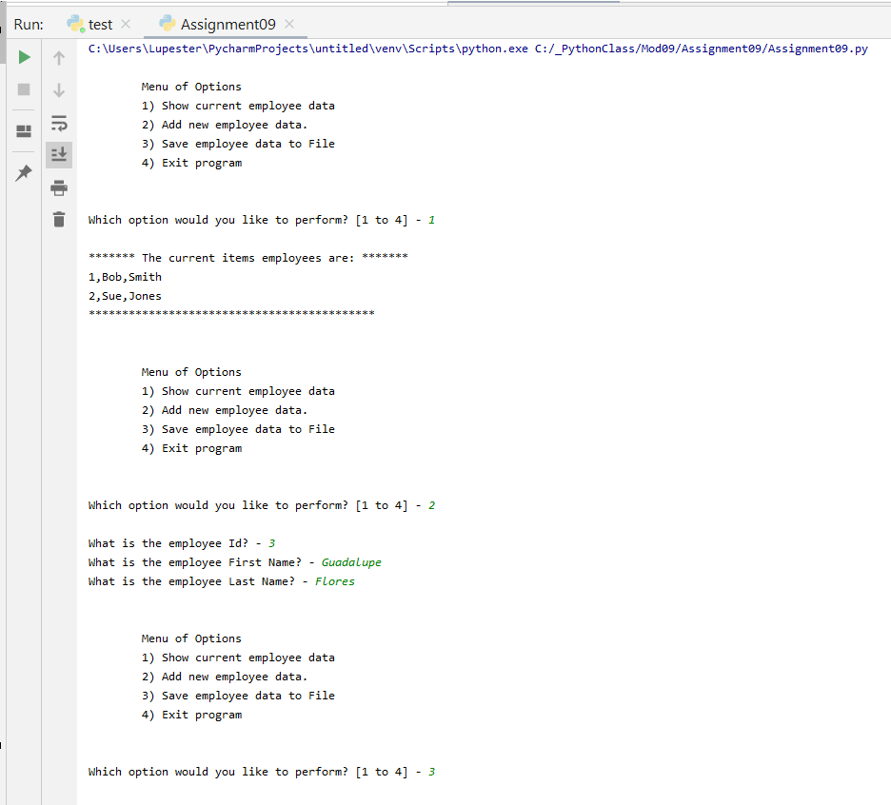 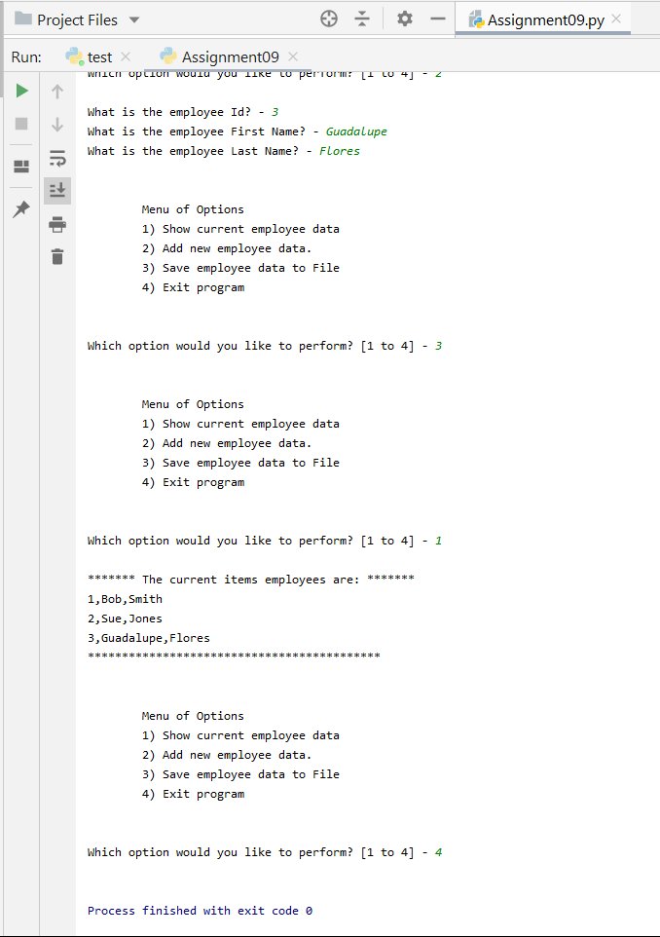

***Figure 4: Lower console output in PyCharm for Module9***

To validate the script is running well, we were also instructed to use a command prompt.

Machine generated alternative text:
menu of Options 
1) Show current employee data 
2) Add new employee data. 
3) Save employee data to File 
4) Exit program 
hich option would you like to perform? [1 to 4] 
The current items employees are: 
1 , Bob , Smith 
2, Sue, Jones 
3 , Guadalupe, Flores 
menu of Options 
1) Show current employee data 
2) Add new employee data. 
3) Save employee data to File 
4) Exit program 
hich option would you like to perform? [1 to 4] 

***Figure 5: Command Prompt Module9***

# Summary

In reading Chapter 9, and reviewing the lecture notes, webpages, practices running the lab assignment and reviewing the tutorials. I was able to create a subfolder and a file and essentially import three modules onto one main, displaying and storing the data results, and uploading the files via GitHub desktop.